Door Greeter

(adapted from “Meaningful Jobs” – Scott May, Principal, Apollo Elementary, Goddard, Kansas)
The Kansas vision for education includes postsecondary and career preparation, social engagement, and communication as the foundational structures of education in our schools and classrooms. From simple jobs in the earliest grades through high school internships, meaningful work supports the academic and social competencies that lead to post-school success.
“Meaningful jobs allow students the opportunity to contribute in a way that both the students and the adults see value. Everyone likes to contribute to their family or workplace in meaningful ways. These responsibilities give students with disabilities or behavior concerns the opportunities to have repeated positive interactions with others and learn from those experiences." - Scott May

The ideas and supports included in these resources are ready to be edited to support growth and independence for individual students.

Job Description
The Door Greeter greets students by name and welcomes visitors as they enter the building.
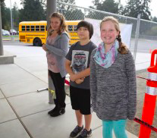
www.thurstontalk.com

Job Duties
Go to the main entrance of the school and stand inside the door.
Greet everyone by saying “hello,” or “Good morning!”
Greet students by name, if possible.
If someone is a visitor, give them directions to the office.
When the first bell rings, go to your homeroom.

Sample visual support
Some students could use a checklist with only words, while others might need words and photos as seen below.
Door Greeter Job
 | - Meet at front door at 7:45.
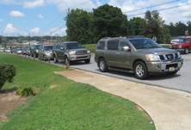 | - Stand facing the drop off area.
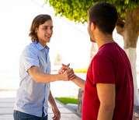 | - When a student walks to the door, say “Hi”, “Hello”, “What’s up”, or “Good morning”.
“Hi, John!”  “Good morning, Amy!”  “Hey, Nate!” | - If I know the student’s name, say “Hi” and then the student’s name.
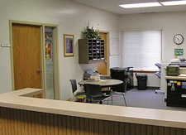 | - If a visitor comes, greet them and take them to the office.
 | - When the bell rings go to homeroom.

Some students might need a simple social narrative to support them in the expectations of the job. A simple script like this could be kept inside a lanyard or pocket for the student to reference.
Greeting People at School
When I am the door greeter I might feel nervous about talking to all of the people coming into the school. This is normal. I can use my visual to remind me of things I can say to people. My visual will be on the inside of my lanyard where I can look at it quickly. When I see someone walking towards the door I will look at them and say “Hey”, or “Hi”, or “What’s up?”. Some people might nod their heads at me or do a fist bump. This is okay. I will watch to see what the other person does then I can do it back. Being the Door Greeter will help me get to know the other students at my school. | What I can say to greet students:  - What’s up?  - Good morning  - Hey  - Hi  - How’s it going?  - Good to see you

The content of this presentation was developed under an agreement from the Federal Department of Education to the Kansas Department of Education. However, those contents do not necessarily represent the policy of the Department of Education, and you should not assume endorsement by the Kansas Department of Education or the Federal Government. TASN Autism and Tertiary Behavior Supports does not discriminate on the basis of race, color, national origin, sex, disability, or age in its’ programs and activities. The following person has been designated to handle inquiries regarding the non-discrimination policies: Deputy Director, Keystone Learning Services, 500 E. Sunflower, Ozawkie, KS 66070, 785-876-2214.

