Office Duster

(adapted from “Meaningful Jobs” – Scott May, Principal, Apollo Elementary, Goddard, Kansas)
The Kansas vision for education includes postsecondary and career preparation, social engagement, and communication as the foundational structures of education in our schools and classrooms. From simple jobs in the earliest grades through high school internships, meaningful work supports the academic and social competencies that lead to post-school success.
“Meaningful jobs allow students the opportunity to contribute in a way that both the students and the adults see value. Everyone likes to contribute to their family or workplace in meaningful ways. These responsibilities give students with disabilities or behavior concerns the opportunities to have repeated positive interactions with others and learn from those experiences." - Scott May

The ideas and supports included in these resources are ready to be edited to support growth and independence for individual students.

Job Description
The Office Duster is responsible for dusting the office shelves, blinds, and tables prior to a special school event.
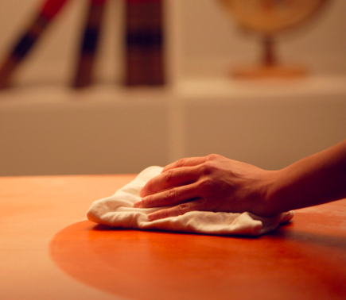
Job Duties
Report to supervisor
Obtain dusting supplies (in Mrs. Martin’s closet)
Dust shelves, blinds, and tables in office
Put supplies away
Return to classroom

Sample visual supports
(Materials created by and used with permission from 2017 EduLync LLC)
Below are checklists and visual supports that might be used to support the student in preparation for this important school job. Some students will benefit from having a checklist with pictures or photos to complete the steps of the job, while others might only need a checklist with words. As you can see, these steps can easily be modified to fit the needs of the student and to align with the requirements of the job in your school.

Dusting
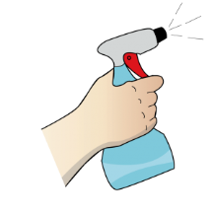
____Get dust rag and spray
____Take items off furniture
____Spray furniture ___ times
____Wipe all parts of furniture
____Put items back on furniture
____Put dust rag and spray away

Dusting
____Get dust rag and spray 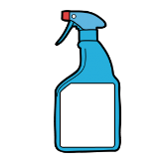
____Take items off furniture
____Spray furniture 3 times
____Wipe all parts of furniture 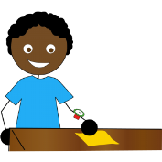
____Put items back on furniture
____Put dust rag and spray away 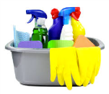

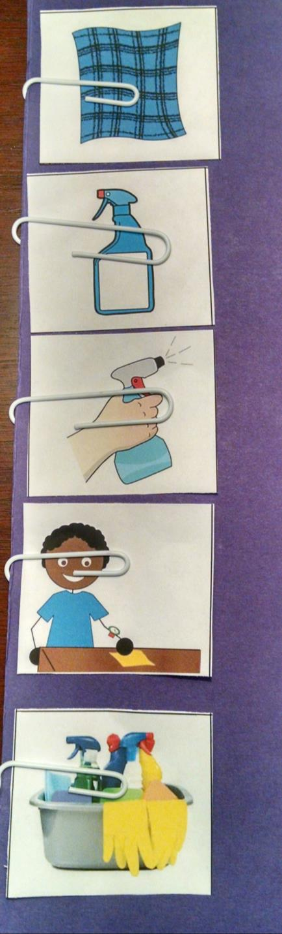
Real photos, or the icons below, could be used to create a flipbook to show the task one step at a time.
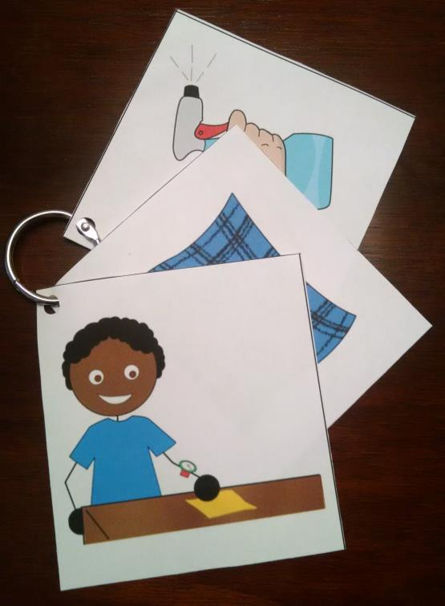

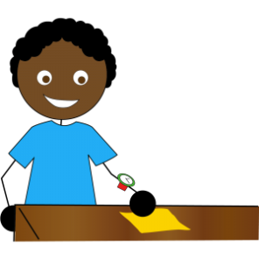
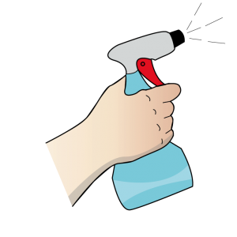

Label surfaces to be dusted with numbers that coordinate with the student’s checklist, so the student knows which areas need to be dusted and in which order. Real photos, or the icons below, could be used.
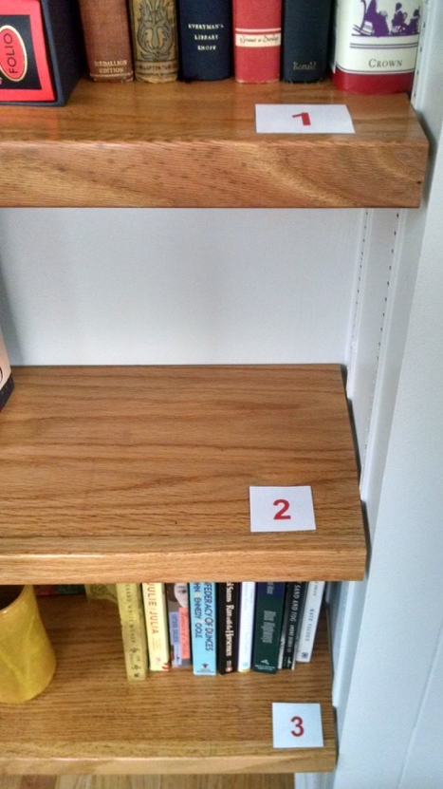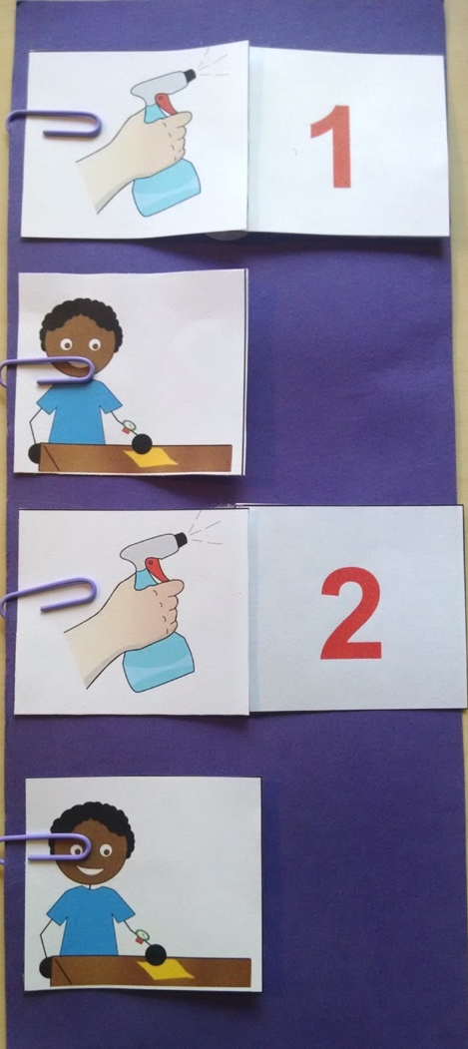

 | 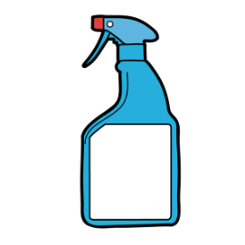 | 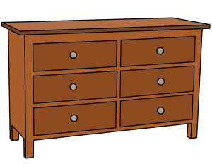
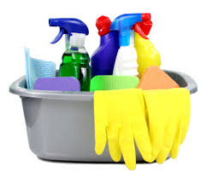 | 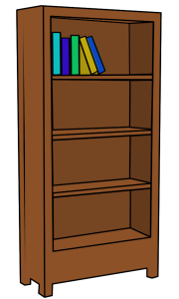 | 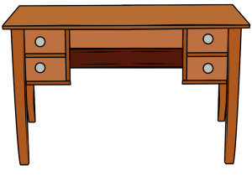
1 | 2 | 3

The content of this presentation was developed under an agreement from the Federal Department of Education to the Kansas Department of Education. However, those contents do not necessarily represent the policy of the Department of Education, and you should not assume endorsement by the Kansas Department of Education or the Federal Government. TASN Autism and Tertiary Behavior Supports does not discriminate on the basis of race, color, national origin, sex, disability, or age in its’ programs and activities. The following person has been designated to handle inquiries regarding the non-discrimination policies: Deputy Director, Keystone Learning Services, 500 E. Sunflower, Ozawkie, KS 66070, 785-876-2214.

